# PROJECT COST MANAGEMENT AND PROJECT SCHDULING

|  |  |  |
| --- | --- | --- |
| **Project Name** | **Duration of the Project** | **Budget of the Project** |
| Solar Panel Integration for Xamar Boarding School | 21 Days | **$** 15,500 |

# Project Cost Management:

Project cost management encompasses various processes involved in planning, estimating, budgeting, and controlling the costs of a project. For the solar panel integration project at Xamar Boarding School, it involves the following key steps:

1. **Plan Cost Management:** This initial step involves outlining how project costs will be estimated, budgeted, and controlled throughout the project lifecycle.
2. **Estimate Costs:** Estimating the costs associated with solar panel procurement, electrical infrastructure upgrades, installation, training, and maintenance.
3. **Determine Budget:** Once the costs are estimated, a budget is determined, considering all project expenses to ensure financial feasibility and accountability.
4. **Control Costs:** Continuously monitoring project expenditures against the budget and taking corrective actions to manage costs within the approved budget.

# Cost Estimation Techniques:

The cost estimation process for the solar panel integration project at Xamar Boarding School involves employing various techniques tailored to the project's specific requirements:

1. **Bottom-Up Estimating:** This methodological approach involves breaking down the project into individual components, such as solar panel procurement, electrical upgrades, installation, training, and maintenance. Each component is evaluated independently before combining the findings to create an all-encompassing cost estimate. Given the intricate nature of the project and the diverse range of components involved, bottom-up estimating allows for a detailed analysis of each element, considering its unique challenges, materials, labor, and associated costs.
2. **Parametric Estimating:** Utilizing statistical data and mathematical models to estimate project costs based on historical data, industry benchmarks, and other relevant sources. While less detailed than bottom-up estimating, parametric estimating provides valuable insights into cost projections, particularly for standardized or repetitive project elements.
3. **Expert Judgment:** Seeking input from subject matter experts with experience in similar projects to provide insights and estimates based on their expertise. Expert judgment enhances the accuracy and reliability of cost estimates, especially in complex projects where historical data may be limited or unavailable.

# Cost Estimation for Solar Panel Integration:

The cost estimation for solar panel integration at Xamar Boarding School involves the following components:

| **Activities** | **Description** | **Cost ($)** |
| --- | --- | --- |
| Site Assessment | Conducting site assessment to determine suitability for solar panel installation | 500 |
| Solar Panel Procurement | Procuring solar panels and related equipment | 4000 |
| Electrical Infrastructure Upgrade | Upgrading electrical infrastructure to support solar panel integration | 3000 |
| Installation | Installing solar panels and connecting them to the electrical system | 2500 |
| Training & Capacity Building | Training staff on system operation and maintenance procedures | 1000 |
| Monitoring & Maintenance | Implementing monitoring systems and scheduling maintenance | 1000 |
| Other Costs | Including permitting, indirect costs, and contingency budget | 1500 |
| **Total** | **Total project cost** | **$15,500** |

**Conclusion:**

Efficient project cost management is essential for ensuring the successful implementation of the solar panel integration project at Xamar Boarding School. By employing the bottom-up estimating technique, supported by parametric estimating and expert judgment, we aim to deliver a cost-effective and sustainable solution that meets the school's energy needs while staying within the allocated budget.

# Work Break-Down Structure (WBS)

# 

# Detailed WBS for Solar Panel Installation at Xamar boarding School’

| **No.** | **Main Task** | **No. Sub-task** | **Responsible Agent** | **Deadline** |
| --- | --- | --- | --- | --- |
| 1 | Project Planning | 1.1 Assess Site Feasibility | Horyal Ass team |  |
|  |  | 1.1.1 Analyze Weather Patterns | Horyal Ass team |  |
|  |  | 1.1.1.1 Conduct Site Assessment | Horyal Ass team |  |
|  |  | 1.1.1.2 Inspect Site Conditions | Horyal Ass team |  |
|  |  | 1.2 Define Project Scope | Site engineer |  |
|  |  | 1.2.1 Identify Project Objectives | Site engineer |  |
|  |  | 1.2.1.1 Define Project Deliverables | Site engineer |  |
|  |  | 1.3 Obtain Permits | Horyal Ass team |  |
|  |  | 1.3.1 Research Permit Requirements | Horyal Ass team |  |
|  |  | 1.3.1.2 Secure Permit Approvals | Horyal Ass team |  |
| 2 | Solar Procurement & Installation | 2.1 Research Technology & Suppliers | Site engineer |  |
|  |  | 2.1.1 Evaluate Solar Panel Options | Site engineer |  |
|  |  | 2.1.1.2 Identify Potential Suppliers | Site engineer |  |
|  |  | 2.2 Coordinate Delivery | Horyal Ass team |  |
|  |  | 2.2.1 Secure Purchase Order | Horyal Ass team |  |
|  |  | 2.2.1.2 Track Delivery Schedule | Horyal Ass team |  |
|  |  | 2.3 Install Solar Panels | Contractors |  |
|  |  | 2.3.1 Prepare Installation Site | Contractors |  |
|  |  | 2.3.1.2 Install and Connect Panels | Contractors |  |
| 3 | Electrical Infrastructure | 3.1 Assess Current Electrical Setup | Site engineer |  |
|  |  | 3.1.1 Conduct Electrical Audit | Site engineer |  |
|  |  | 3.1.1.2 Determine Upgrade Needs | Site engineer |  |
|  |  | 3.2 Upgrade for Integration | Site engineer |  |
|  |  | 3.2.1 Design Upgrade Plan | Site engineer |  |
|  |  | 3.2.1.2 Implement Electrical Upgrades | Site engineer |  |
|  |  | 3.3 Ensure Compliance | Site engineer |  |
|  |  | 3.3.1 Research Electrical Codes | Site engineer |  |
|  |  | 3.3.1.2 Obtain Electrical Inspection | Horyal Ass team |  |
| 4 | Training & Capacity Building | 4.1 Develop Training Materials | Site engineer |  |
|  |  | 4.1.1 Create Operation Manuals | Site engineer |  |
|  |  | 4.1.1.2 Develop Maintenance Procedures | Site engineer |  |
|  |  | 4.2 Conduct Training Sessions | Horyal Ass team |  |
|  |  | 4.2.1 Train Staff on System Operation | Horyal Ass team |  |
|  |  | 4.2.1.2 Train Staff on Maintenance Procedures | Horyal Ass team |  |
|  |  | 4.3 Provide Ongoing Support | Horyal Ass team |  |
|  |  | 4.3.1 Offer Technical Assistance | Horyal Ass team |  |
|  |  | 4.3.1.2 Address Questions and Concerns | Horyal Ass team |  |
| 5 | Monitoring & Maintenance | 5.1 Implement Monitoring Systems | Contractors |  |
|  |  | 5.1.1 Install Data Tracking Equipment | Contractors |  |
|  |  | 5.1.1.2 Configure Monitoring Software | Contractors |  |
|  |  | 5.2 Schedule Maintenance | Horyal Ass team |  |
|  |  | 5.2.1 Develop Maintenance Schedule | Horyal Ass team |  |
|  |  | 5.2.1.2 Assign Maintenance Tasks | Horyal Ass team |  |
|  |  | 5.3 Address Issues Promptly | Horyal Ass team |  |

# Network diagram

A network diagram serves as a visual representation illustrating the sequence and dependencies of tasks and activities within the Solar Panel Project. It aids in comprehending the interconnections between various project activities, their durations, and the critical path necessary for project completion.

For the team at Xamar boarding school, crafting a network diagram for the Solar Panel Project offers invaluable insights into the project's workflow. By delineating the logical relationships among activities, this diagram empowers the team to meticulously plan, schedule, and monitor the project's progress. In line with the guidelines provided by the Project Management Institute (PMI), a network diagram for the Solar Panel Project acts as a schematic display of the logical sequencing of project activities. This visualization facilitates the development of project schedules, identification of critical path activities, and fosters seamless communication among project team members

# Table of dependencies

| **Task** | **Description** | **Predecessors** | **Duration (Days)** |
| --- | --- | --- | --- |
| A | Site Assessment | - | 3 |
| B | Solar Panel Procurement | A | 3 |
| C | Electrical Infrastructure Upgrade | A | 5 |
| D | Install Solar Panels | B | 4 |
| E | Electrical System Upgrade | C | 3 |
| F | Training Session | D, E | 3 |

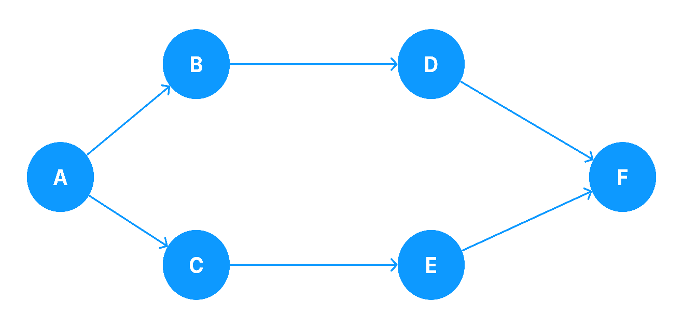

# CPM network diagram

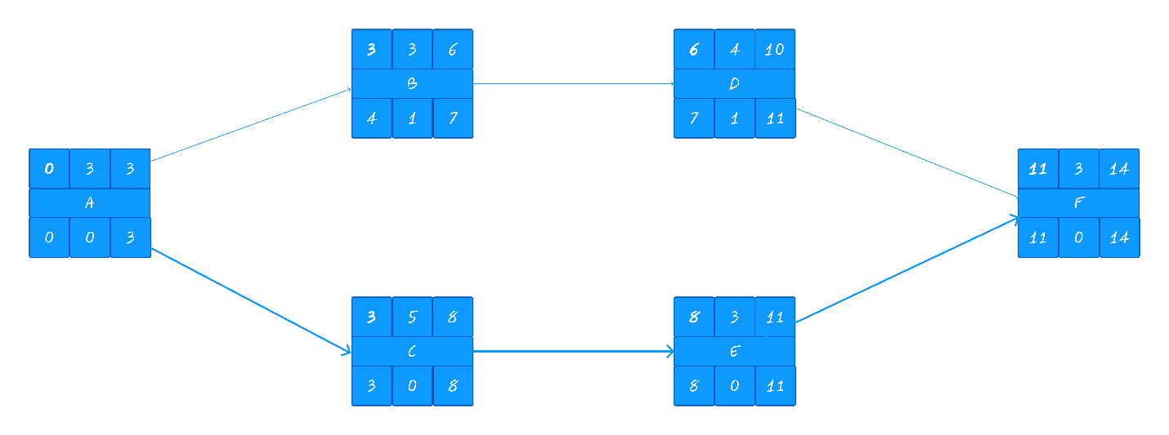

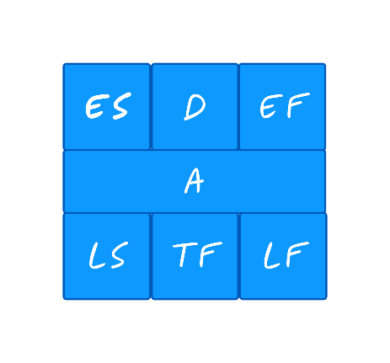ES = Early Start.  
EF = Early Finish.  
  
LS = Late Start.   
LF = Late Finish.  
  
D = Duration.  
TF = Total Float.  
ES = ES + D  
LS = LF - D  
LF = ES-D          
TF = LF - EF or LS - ES

CP 🡺